**41) create bucket-1(ap-south-1) and upload files(t1,t2,t3) into it**

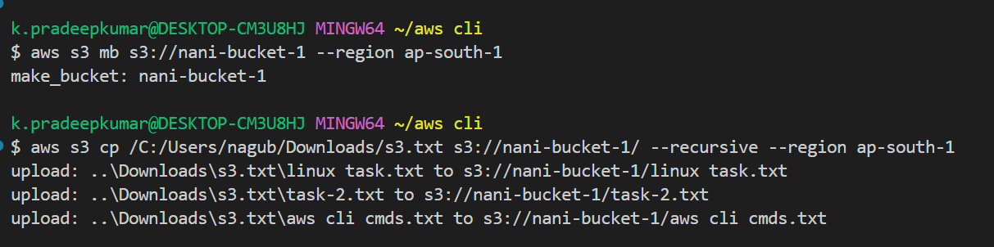

**42) Create bucket-2(ap-souht-1) and upload files(t4,t5,t6) into it**

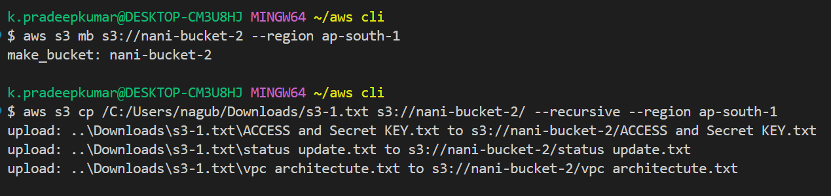

**43) Copy files from bucket-1 to bucket-2. so that bucket-2 should have all 6 files**

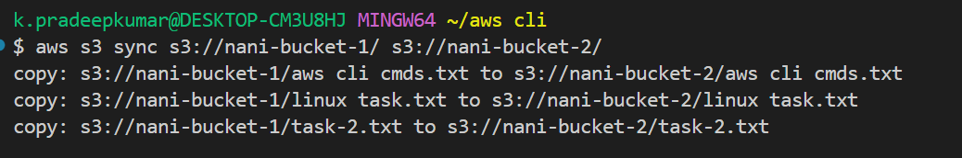

**44) Create bucket-3(us-east-1) and upload files(t7,t8,t9)**

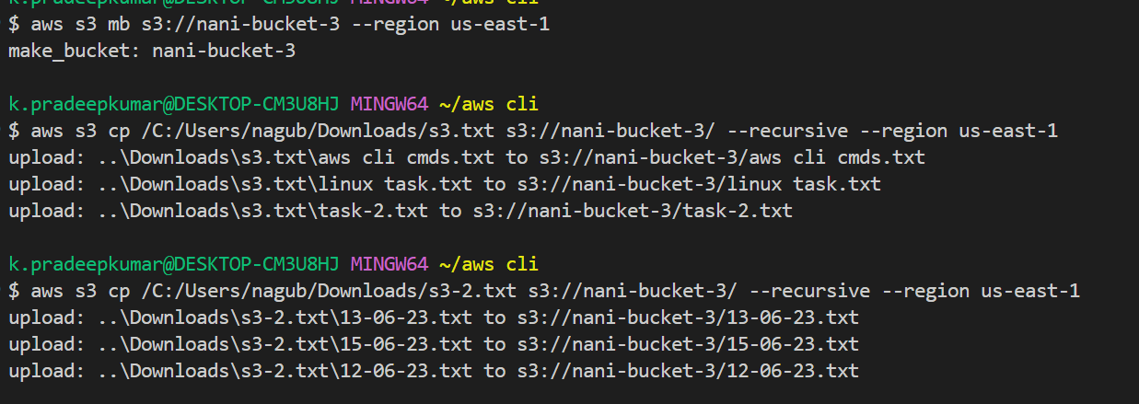

**45) Copy files from bucket-1(ap-south-1) to bucket-3(us-east-1).**

